**Assignment -4**

|  |  |
| --- | --- |
| Assignment Date | 19 October 2022 |
| Student Name | Ovya M |
| Student Roll Number | 722819104093 |
| Maximum Marks | 2 Marks |

**Question-1:**

# Write code and connections in wokwi for ultrasonic sensor.

Whenever distance is less than 100cms send “alert” to IBM cloud and display in device

# recent events.

***Wokwi Project Link:*** <https://wokwi.com/projects/346235279031403092>

#include <WiFi.h> #include <PubSubClient.h> #define TRIGGER 2

#define ECHO 15

#define sound_speed 0.034 int distance;

void callback(char* subscribetopic, byte* payload, unsigned int payloadLength);

//-------credentials of IBM Accounts------

#define ORG "sgoqkq"

#define DEVICE_TYPE "Gas_Leakage_Detection_Device" #define DEVICE_ID "Gas_Leakage_Detection_Device1" #define TOKEN "123456789"

String data3;

//-------- Customise the above values --------

char server[] = ORG ".messaging.internetofthings.ibmcloud.com"; char publishTopic[] = "iot-2/evt/Data/fmt/json";

char subscribetopic[] = "iot-2/cmd/test/fmt/String"; char authMethod[] = "use-token-auth";

char token[] = TOKEN;

char clientId[] = "d:" ORG ":" DEVICE_TYPE ":" DEVICE_ID;

// - WiFiClient wifiClient;

PubSubClient client(server, 1883, callback ,wifiClient); void setup()

{

**Serial**.begin(115200); pinMode(TRIGGER, OUTPUT); pinMode(ECHO, INPUT); delay(10); **Serial**.println(); wificonnect();

mqttconnect();

}

void loop()

{

digitalWrite(TRIGGER, HIGH); delayMicroseconds(10); digitalWrite(TRIGGER, LOW);

int duration=pulseIn(ECHO,HIGH); distance=(duration*sound_speed)/2; **Serial**.print("Distance:"); **Serial**.print(distance); **Serial**.println("cms"); if(distance<100){

PublishData(distance);

}

delay(1000);

if (!client.loop()) { mqttconnect();

}

}

/*.....................................retrieving to

Cloud. */

void PublishData(int d) { mqttconnect();

String payload = "{\"message\":\"alert\"}";

**Serial**.print("Sending payload: ");

**Serial**.println(payload);

if (client.publish(publishTopic, (char*) payload.c_str())) {

**Serial**.println("Publish ok");

} else {

**Serial**.println("Publish failed");

}

}

void mqttconnect() {

if (!client.connected()) { **Serial**.print("Reconnecting client to "); **Serial**.println(server);

while (!!!client.connect(clientId, authMethod, token)) {

**Serial**.print("."); delay(500);

}

initManagedDevice();

**Serial**.println();

}

}

void wificonnect()

{

**Serial**.println(); **Serial**.print("Connecting to ");

WiFi.begin("Wokwi-GUEST", "", 6); while (WiFi.status() != WL_CONNECTED) {

delay(500);

**Serial**.print(".");

}

**Serial**.println(""); **Serial**.println("WiFi connected"); **Serial**.println("IP address: "); **Serial**.println(WiFi.localIP());

}

void initManagedDevice() {

if (client.subscribe(subscribetopic)) { **Serial**.println((subscribetopic)); **Serial**.println("subscribe to cmd OK");

} else {

**Serial**.println("subscribe to cmd FAILED");

}

}

void callback(char* subscribetopic, byte* payload, unsigned int payloadLength)

{

**Serial**.print("callback invoked for topic: ");

**Serial**.println(subscribetopic);

for (int i = 0; i < payloadLength; i++) { data3 += (char)payload[i];

}

**Serial**.println("data: "+ data3);

data3="";

}

**Wokwi Platform Coding and Circuit Design**

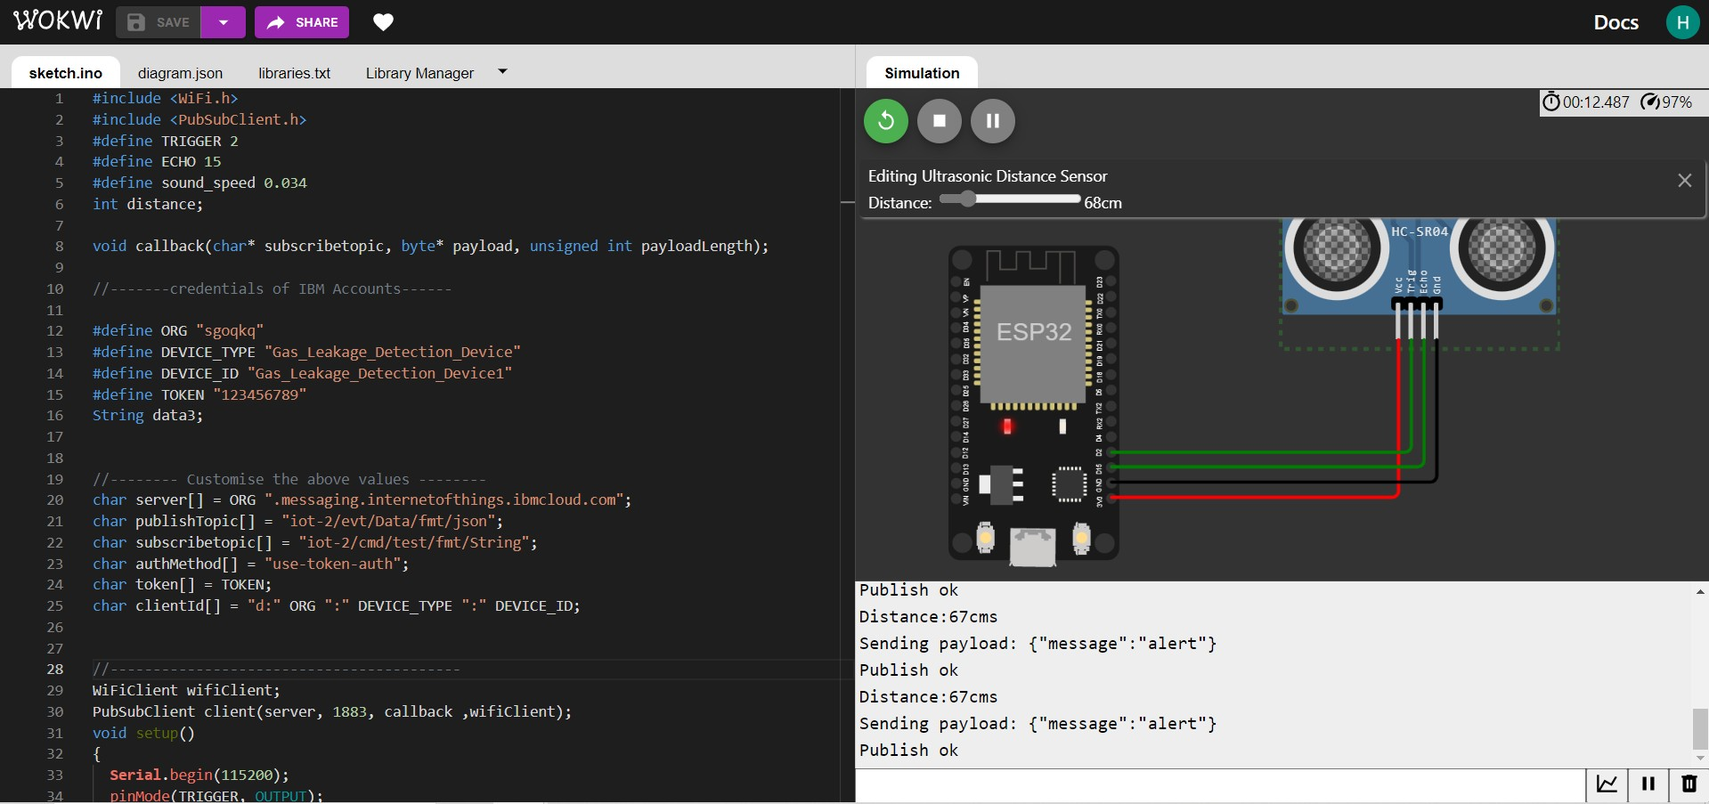

**IBM IoT Platform Device Recent Events**

